**Example 1: Write a program to calculate the average of three numbers and take a condition to calculate other set of numbers.**

|  |
| --- |
| #include <iostream>  using namespace std;  int main()  {  int s1,s2,s3;  double average;  char again;  do  {  cout<<"Enter the three scors";  cin>>s1>>s2>>s3;  average =(s1+s2+s3)/3;  cout<<"The average is "<<average <<"\n";  cout<<"Do you want to average another set? (Y/N)";  cin>>again;  }  while(again=='Y'|| again=='y');  return 0;  } |

Output

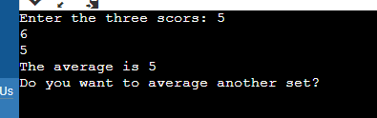

**Example 2: Write a C++ program to implement the Number Guessing Game. In this game the computer chooses a random number between 1 and 100, and the player tries to guess the number in as few attempts as possible. Each time the player enters a guess, the computer tells him whether the guess is too high, too low, or right. Once the player guesses the number, the game is over.**

|  |
| --- |
| #include <iostream>  #include <cstdlib>  #include <ctime>  using namespace std;  int main()  {  int num, guess, tries = 0;  srand(time(0)); //seed random number generator  num = rand() % 100 + 1; // random number between 1 and 100  cout<<num;  cout << "Guess My Number Game\n\n";  do  {  cout << "Enter a guess between 1 and 100 : ";  cin >> guess;  tries++;  if (guess > num)  cout << "Too high!\n\n";  else if (guess < num)  cout << "Too low!\n\n";  else  cout << "\nCorrect! You got it in " << tries << " guesses!\n";  } while (guess != num);  return 0;  } |

Output

